Annual Report 2022/2023
Properties and Burials Committee Summary - Cllr. Colin Gilbert
Responsibilities include the two cemeteries, St Dunstan’s Churchyard, the Vestry Hall Complex, the War Memorials, bus shelters, noticeboards, cycle racks and red telephone boxes.
Vestry Hall Complex – Exploring options to replace the old central heating system, lighting systems etc. with a view to consider the use of alternative technology. New thermal curtains have been installed into the Vestry Hall. Looking forward we are exploring the possible installation of secondary glazing.
Public toilets, Crane Lane - We have managed to keep the toilets open despite the attempts of vandalism. Our thanks go to our cleaners who have done and continue to do a great job.
Environmental Management Committee Summary - Cllr. Alan Kings
Responsibilities include managing Recreation Grounds, Allotments, Streetlighting and Car Parks
Electric vehicle charging points, Jockey Lane - Due to the increased electricity charges, the EV units have moved to a private network. The reimbursement rate from BP Pulse would not cover the electric costs if they remained on the BP Pulse Public Network
Streetlights – numerous lights have required maintenance, with some needing replacing.
Plans for 2023/24 include Recreation Grounds & Nature Reserve tree safety audit and Highway Improvement Plan
Planning & Preservation Committee Summary - Cllr. Alison Bunyan
The Parish Council are statutory consultees, with TWBC the decision-making authority. The main responsibility of the committee is to consider and make comments on planning applications, appeals and other planning documents including consultations. The committee dealt with 142 planning applications during the year.
The Secretary of State for Housing, Michael Gove, turned down Berkeley Homes application to build 165 houses adjacent to Turnden. Under planning law, building in Area’s of Outstanding Natural Beauty should be avoided except in exceptional circumstances. Mr Gove concluded that “exceptional circumstances do not exist to justify the proposed development in the AONB and that the development would not be in the public interest.” Berkeley Group has launched a legal challenge against the housing secretary’s decision.
Community Development Committee – Cllr. Lee Hatcher
The committee’s aim is to promote events, tourism, social cohesion and facilitate community involvement.
The committee has facilitated the reinstatement of the weekly Citizens Advice outreach sessions in Cranbrook Library. A ‘New Year, New You’ event was successfully held in Vestry Hall. This was to showcase local organisations who were looking for new members or volunteers.
Looking forward the committee plans to develop effective liaison with outside bodies on car parking and traffic issues, create and develop Parish Voluntary Organisation liaison and develop a public consultation policy for the Council.
Neighbourhood Development Planning Committee Summary - Cllr. Garry Pethurst
Following the Regulation 16 Consultation last September, an independent Examiner was appointed and his Clarification Note was received at the beginning of the year and, working jointly with TWBC, a response was sent. It is hoped that the plan will be at the Referendum Stage in September.
Policy and Resources Committee – Cllr. Garry Pethurst
The P&R committee is made up of the chairs of all the other committees, including the chair of the PC. It is, in effect, the Finance committee with responsibility for ensuring that the Council’s finances are managed prudently, to try to obtain best value for money for all our parishioners.
We are aware that everybody will be impacted is some way by the cost-of-living crisis, and the Parish Council was determined to try to do its bit to keep its impact down. Therefore, we took the decision to maintain the Precept at last year’s level by budgeting cautiously and, where necessary, using some of the reserves put by in previous years.
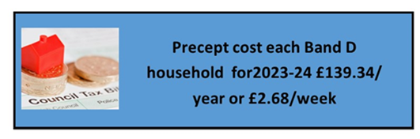
Finance Report

Total Expenditure 2022/23 - £418,587, includes:

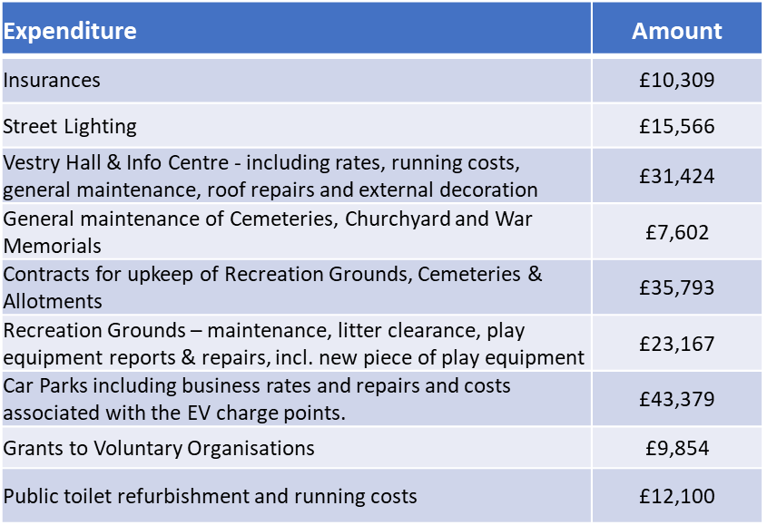
Revenue Sources 2022/23:
